NEXTAG COMPANY

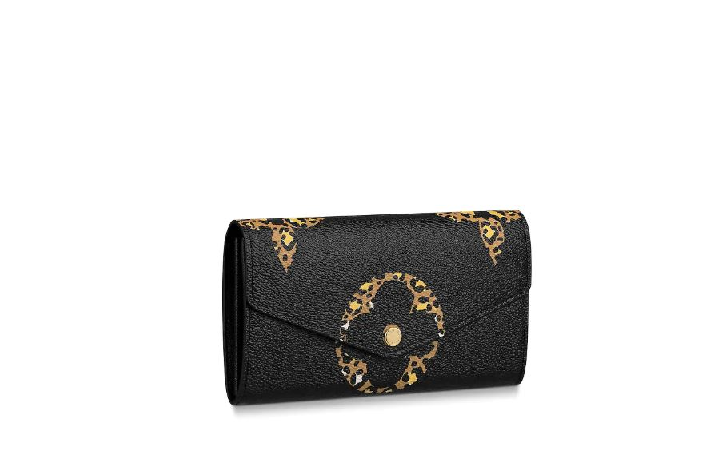LOUIS VUITTON - SARAH WALLET

##### **Detail**

The Sarah wallet gets a bold new look as part of the LV Jungle special edition of accessories and leather goods. It comes in Monogram Giant canvas, which is revisited with a graphic animal print. This classic envelope-style wallet opens to reveal a well-organized interior with a variety of pockets and card slots.

• Monogram Giant coated canvas

• Grained cowhide-leather lining

• Gold-color hardware

• Press-stud closure

• Zipped coin pocket

• 19.0 x 10.5 x 2.0 cm (Length x Height x Width)

##### **CARE & COMPOSITION**

* leather
* imported